**EXPERIMENT NO.8**

AIM: To design an ALU.

IC USED: 74153(4×1 MUX), 7432(OR), 7404(NOT), 7408(AND), 7486(XOR).

THEORY: In computing, an **arithmetic logic unit** (**ALU**) is a digital circuit that performs arithmetic and logical operations. The ALU is a fundamental building block of the central processing unit (CPU) of a computer, and even the simplest microprocessors contain one for purposes such as maintaining timers. The processors found inside modern CPUs and graphics processing units (GPUs) accommodate very powerful and very complex ALUs; a single component may contain a number of ALUs.

Mathematician John von Neumann proposed the ALU concept in 1945.

Below is a block diagram for an ALU:

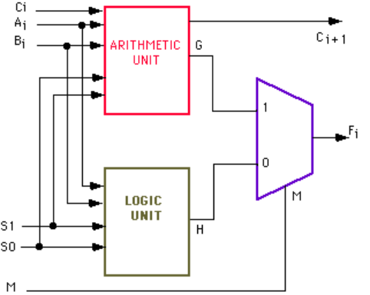

SCHEMATIC:

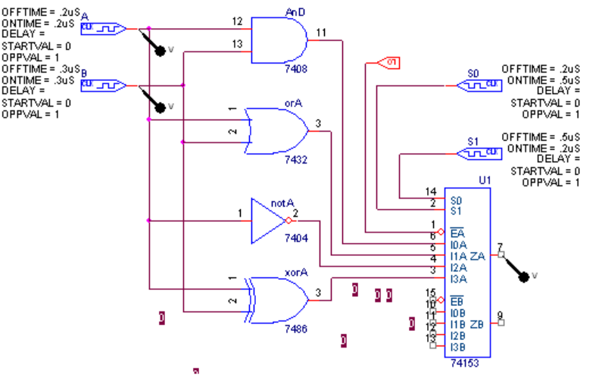

WAVEFORM:

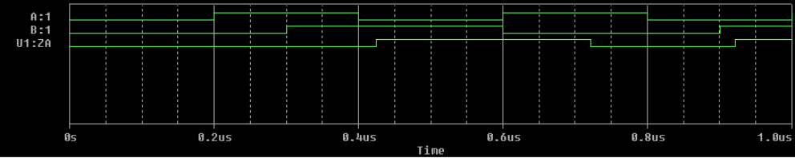

RESULT: The ALU is designed and its output is verified.